

Vintage French Carnival Rides Make Grand Entrance on Governors Island
July 12, 2013 2:30 PM
Francophiles abound at UnBeige HQ, and with Bastille Day approaching, we sent writer Nancy Lazarus to preview the world’s first traveling festival of vintage carnival rides and carousels as it makes its stateside debut.
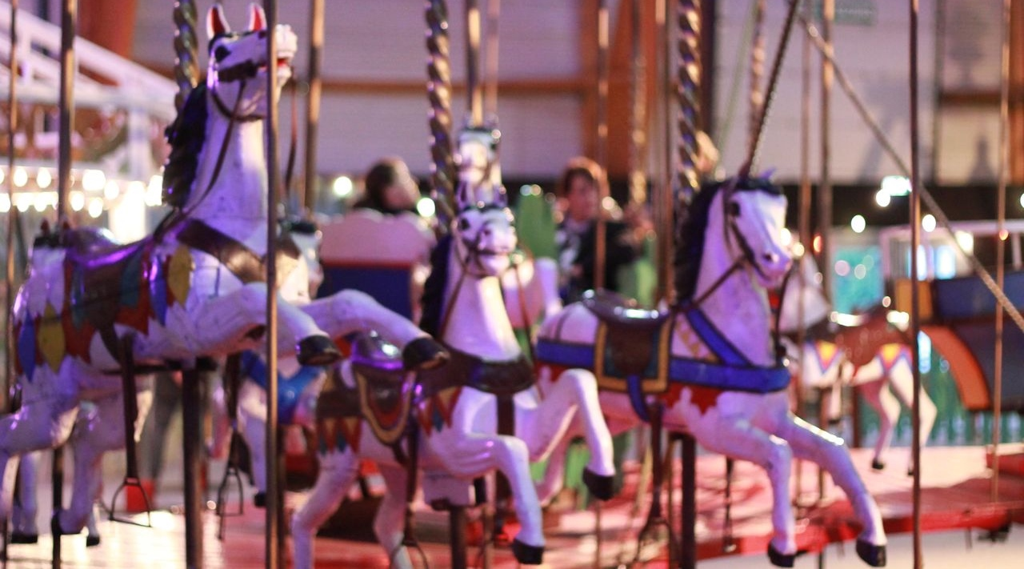
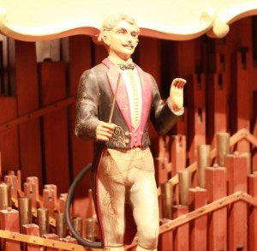Lady Liberty is green with envy. While the famous statue just reopened to the public, another French attraction, Fête Paradiso, makes its debut tomorrow on a neighboring isle in New York Harbor. The collection of late 19th and early 20th century carousels, swing sets, pipe organ, and games arrived here after six months of planning and a four-week installation period (by a French artisan family that rebuilt the rides on the island). The carnival rides will be open and operational during weekends through September 29.
“Governors Island is known for its fantastic view of the Statue of Liberty, and now we can further celebrate French-American relations,” said Leslie Koch, president of The Trust for Governors Island during a preview this week. She noted that the event’s exotic name derives from the film Cinema Paradiso, though “it’s hard to imagine it all here in the middle of New York City.”
“I’ve come to New York with my toys, after many years of dreaming about restoring this ménage,” explained Fête Paradiso’s creative director and carnival rides collector, Régis Masclet. “I’d been working alone on these French festivals, but after a wonderful encounter with fellow collector Roger Staub, I’ve been allowed to realize my dream.”
“This terrain on Governors Island reunites different rides dating from 1850 through 1960, and each represents a different epoch and technical advances of that era,” Masclet said. “It starts with steam-powered rides, through the industrial revolution, where mechanical and electrical processes were replaced by bikes, cars and planes. In this private collection, we see the evolution of these rides.”
“Carousels were the first social network where people could meet each other,” observed Tristan Duval, producer at Community, a French event promotion firm. “Carousels were first built only for adults and were later designed for children,” he added.
Et voilà —a tour of some collection highlights:
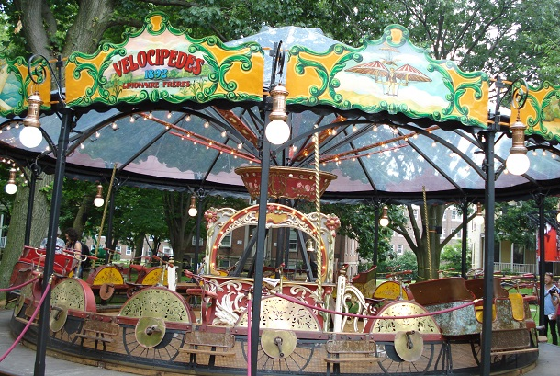
Bicycle Carousel: The Limonair family designed the ride in the 1890s to teach people to use bicycles, explained Robert Arbor, founder of Le Gamin bistro at Fête Paradiso. The carousel is powered by an electrical engine or by riders pedaling, and media attendees went on a test ride.
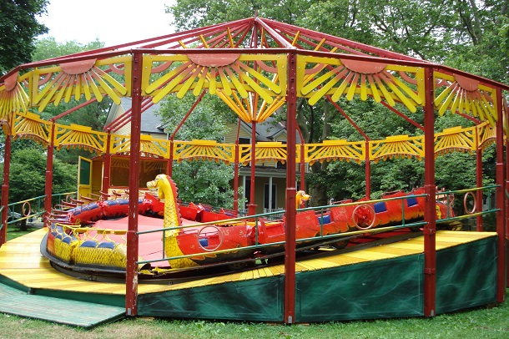
Chinese Dragon Carousel: Displaying bright primary colors, the ride was built after World War 1. It runs counterclockwise at varying speeds. According to Chris Wangro, USA producer at Zaragunda Inc., one must jump onto the ride while it’s moving, though he didn’t demonstrate.
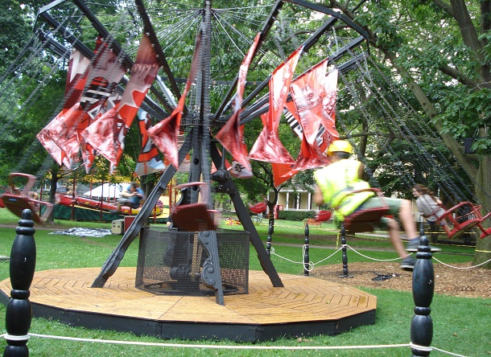
Flying Chairs: The name of this ride says it all. Red banners and chairs are suspended from a rotating black base by attached spokes. When we saw it in motion, a few construction workers took it for a whirlwind spin.
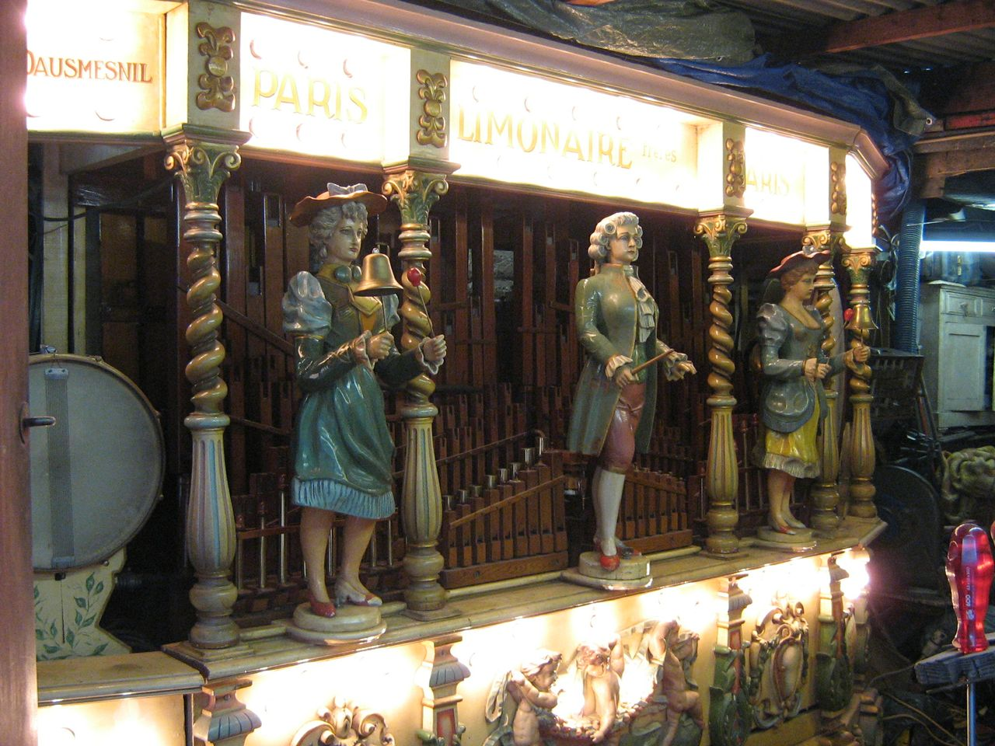
Pipe Organ: Constructed in 1910, this “call organ” was designed to attract carnival visitors With 92 keys, it operates by punch cards. When festival organizers cranked it up, it sounded brand new.
Bumper Car Pavilion / Café: Alas, the bumper cars, designed in 1900, were too heavy to transport from France. Pas de problème, since the large wooden pavilion structure will function as a temporary outpost for Le Gamin bistro, serving a full menu with French classics like crepes, salade Nicoise, organic wine from Languedoc, as well as green apple cotton candy.
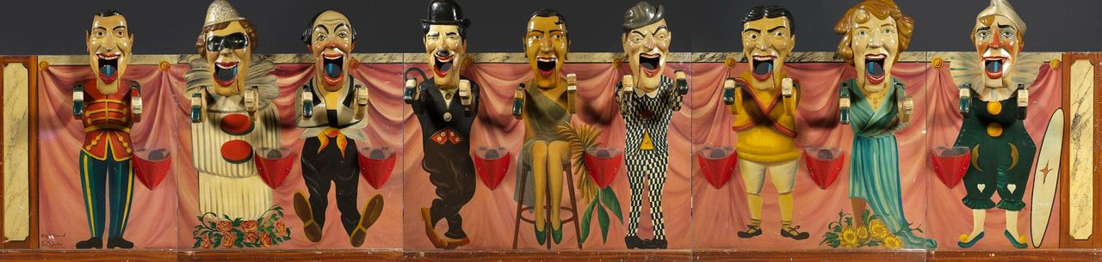
These rides, along with horses and gondola carousels and a “music hall ball guzzler” (above), operate using older technologies. Nevertheless, Fête Paradiso is also active on social networks, though so far there have been no salutary tweets from Lady Liberty.
Nancy Lazarus is a contributor to UnBeige.

